Working Queries

sssss

1. CREATE DATABASE assignment;

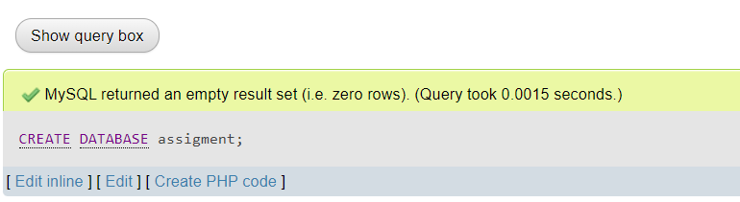

2) CREATE TABLE EMPLOYEE(

Fname CHAR(200),

Minit CHAR(10),

Lname CHAR(200),

Ssn int PRIMARY KEY,

Bdate DATE,

Address VARCHAR(200),

Sex CHAR(10),

Salary int,

Super_ssn int,

FOREIGN KEY (Super_ssn)

REFERENCES EMPLOYEE(Ssn)

ON UPDATE CASCADE

ON DELETE CASCADE

) ENGINE=INNODB;

